VERUCCA NEEDLING
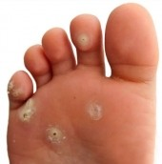
What is it?
Falknor`s needling procedure is an innovative and effective treatment for verruca, which are benign types of the Human Papilloma Virus (HPV) group. It is a form of soft tissue therapy which is intended to break down the verruca and create a controlled inflammatory response which, in turn, stimulates the body’s immune system to recognise the virus and destroy it.
Verruca Needling treatment has been around for over 45 years (being first described in a medical journal in America in 1969) and is used routinely with great success by practitioners internationally. It has been reported to be highly effective, even for long-standing verruca.
Verruca Needling is different from other treatment options such as cryotherapy or salicylic acid as it requires only one or occasionally two sessions. This makes it an ideal treatment option for busy people. The treatment is carried out under local anesthetic. Most people report only minor soreness for 2 to 3 days post-treatment.
How does Verruca Needling Work?
Verruca Needling works by puncturing the verruca with an empty sterile needle many times, the viral particles are directly exposed to the fatty tissue beneath the skin where the body is rich in immune regulators. Here, the immune system can recognise and destroy the virus. As this immune response is often systemic, treatment of only one verruca is required even where there are many lesions as spontaneous remission can occur in all, or most, verruca at the same time.

What will happen during the treatment?
There are three stages to the Verruca Needling procedure:
Step 3
DRESSING APPLICATION
A dressing will be applied to the verruca once the procedure is completed. You are advised not to drive when the foot or part of the foot has been anaesthetised.
Step 1
LOCAL ANESTHETIC
You will be given an injection of local anesthetic which will make your verruca and surrounding area numb.
Step 2
VERRUCA NEEDLING
Once the verruca is numb, the podiatrist will carefully needle the verrucae to implant the virus into the dermal layer of the skin so that the body’s immune system can come into contact with the virus

Will it be painful afterwards?
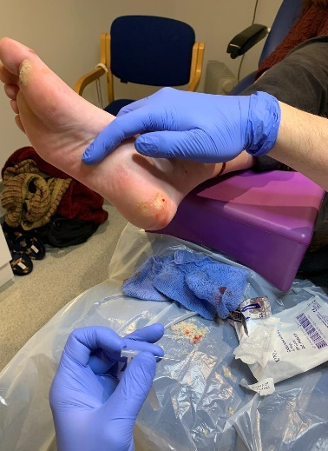
Some patients can experience soreness once the anaesthetic wares off. This soreness can best be described as a bruised feeling that can last for up to 7/10 days however most patient describe soreness only for 2 to 3 days after the procedure. Painkillers such as Paracetamol are normally sufficient to reduce any discomfort. Use of Ibuprofen or any other anti-inflammatory medication is not advisable, but you can use Paracetamol.
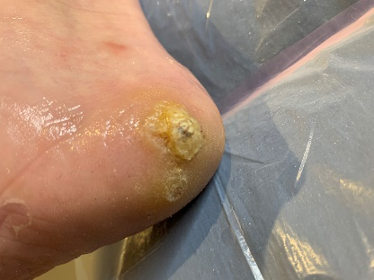
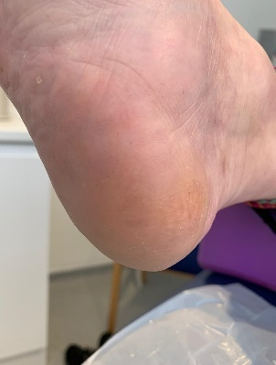
BEFORE
AFTER

Enquire at the Clinic for Appointment availability. Please note patient will be unable to drive post procedure.
Clinic Contact Details: 19A South Street, St Neots, Pe19 2bw Tel: 01480 532883

